

Splitting a sales dataset into monthly subset using tidyr

A PROJECT REPORT

Submitted by

NEHA HENIN J (2303811714822025)

in partial fulfillment of requirements for the award of the course

AGI1252-FUNDAMENTALS OF DATASCIENCE USING R

in

ARTIFICIAL INTELLIGENCE AND MACHINE LEARNING

K. RAMAKRISHNAN COLLEGE OF TECHNOLOGY
(An Autonomous Institution, affiliated to Anna University Chennai and Approved by AICTE, New Delhi)

SAMAYAPURAM – 621 112

JUNE 2025

i

K. RAMAKRISHNAN COLLEGE OF TECHNOLOGY (AUTONOMOUS)
SAMAYAPURAM – 621 112

BONAFIDE CERTIFICATE

Certified that this project report on “Splitting a sales dataset into monthly subset using tidyr” is the Bonafide work of NEHA HENIN J (2303811714822025) who carried out the project work during the academic year 2024 - 2025 under my supervision.
SIGNATURE | SIGNATURE
Dr.T.AVUDAIAPPAN, M.E.,Ph.D., | Mrs. SRI SANTHOSHINI, M.E.,
HEAD OF THE DEPARTMENT | SUPERVISOR
ASSOCIATE PROFESSOR | ASSISTANT PROFESSOR
Department of Artificial Intelligence | Department of Artificial Intelligence
K.Ramakrishnan College of Technology (Autonomous) | K.Ramakrishnan College of Technology (Autonomous)
Samayapuram–621112. | Samayapuram–621112.

Submitted for the viva-voce examination held on …02.06.2025……………….

INTERNAL EXAMINER | EXTERNAL EXAMINER  ii

DECLARATION

I declare that the project report on “Splitting a sales dataset into monthly subset using tidyr” is the result of original work done by me and best of my knowledge, similar work has not been submitted to “ANNA UNIVERSITY CHENNAI” for the requirement of Degree of BACHELOR OF ENGINEERING. This project report is submitted on the partial fulfilment of the requirement of the completion of the course AGI1252-FUNDAMENTALS OF DATASCIENCE USING R.

Signature
NEHA HENIN J

Place: Samayapuram
Date:02/06/2025

iii

ACKNOWLEDGEMENT

It is with great pride that I express our gratitude and in-debt to our institution “K.Ramakrishnan College of Technology (Autonomous)”, for providing us with the opportunity to do this project.

I glad to credit honourable chairman Dr. K. RAMAKRISHNAN, B.E., for having provided for the facilities during the course of our study in college.

I would like to express our sincere thanks to our beloved Executive Director Dr. S. KUPPUSAMY, MBA, Ph.D., for forwarding to our project and offering adequate duration in completing our project.

I would like to thank Dr. N. VASUDEVAN, M.Tech., Ph.D., Principal, who gave opportunity to frame the project the full satisfaction.

I whole heartily thanks to Dr. T. AVUDAIAPPAN, M.E.,Ph.D., Head of the department, ARTIFICIAL INTELLIGENCE for providing his encourage pursuing this project.

I express our deep expression and sincere gratitude to our project supervisor
Mrs E. SRI SANTHOSHINI, M.E.,, Department of ARTIFICIAL
INTELLIGENCE, for her incalculable suggestions, creativity, assistance and patience which motivated us to carry out this project.

I render our sincere thanks to Course Coordinator and other staff members for providing valuable information during the course.

I wish to express our special thanks to the officials and Lab Technicians of our departments who rendered their help during the period of the work progress.

iv

INSTITUTE
Vision:
- To serve the society by offering top-notch technical education on par with global standards.
Mission:
- Be a center of excellence for technical education in emerging technologies by exceeding the needs of industry and society.
- Be an institute with world class research facilities.
- Be an institute nurturing talent and enhancing competency of students to transform them as all – round personalities respecting moral and ethical values.

DEPARTMENT
Vision:

- To become a renowned hub for AIML technologies to producing highly talented globally recognizable technocrats to meet industrial needs and societal expectation.

Mission

- To impart advanced education in AI and Machine Learning, built upon a foundation in Computer Science and Engineering.
- To foster Experiential learning equips students with engineering skills to tackle real-world problems.
- To promote collaborative innovation in AI, machine learning, and related research and development with industries.
- To provide an enjoyable environment for pursuing excellence while upholding strong personal and professional values and ethics.

v

PROGRAM EDUCATIONAL OBJECTIVES (PEO)

- PEO1: Excel in technical abilities to build intelligent systems in the fields of AI & ML in order to find new opportunities.
- PEO2: Embrace new technology to solve real-world problems, whether alone or as a team, while prioritizing ethics and societal benefits.
- PEO3: Accept lifelong learning to expand future opportunities in research and product development.

PROGRAM SPECIFIC OUTCOMES (PSO)
- PSO1: Expertise in tailoring ML algorithms and models to excel in designated applications and fields.
- PSO2: Ability to conduct research, contributing to machine learning advancements and innovations that tackle emerging societal challenges.

PROGRAM OUTCOMES (POs)
Engineering students will be able to:
- Engineering knowledge: Apply the knowledge of mathematics, science, engineering fundamentals, and an engineering specialization to the solution of complex engineering problems.
- Problem analysis: Identify, formulate, review research literature, and analyze complex engineering problems reaching substantiated conclusions using first principles of mathematics, natural sciences, and engineering sciences
- Design/development of solutions: Design solutions for complex engineering problems and design system components or processes that meet the specified needs with appropriate consideration for the public health and safety, and the cultural, societal, and environmental considerations
- Conduct investigations of complex problems: Use research-based knowledge and research methods including design of experiments.
vi
- Modern tool usage: Create, select, and apply appropriate techniques, resources, and modern engineering and IT tools including prediction and modeling to complex engineering activities with an understanding of the limitations
- The engineer and society: Apply reasoning informed by the contextual knowledge to assess societal, health, safety, legal and cultural issues and the consequent responsibilities relevant to the professional engineering practice
- Environment and sustainability: Understand the impact of the professional engineering solutions in societal and environmental contexts, and demonstrate the knowledge of, and need for sustainable development
- Ethics: Apply ethical principles and commit to professional ethics and responsibilities and norms of the engineering practice.
- Individual and team work: Function effectively as an individual, and as a member or leader in diverse teams, and in multidisciplinary settings.
- Communication: Communicate effectively on complex engineering activities with the engineering community and with society at large, such as, being able to comprehend and write effective reports and design documentation, make effective presentations, and give and receive clear instructions.
- Project management and finance: Demonstrate knowledge and understanding of the engineering and management principles and apply these to one’s own work, as a member and leader in a team, to manage projects and in multidisciplinary environments.
- Life-long learning: Recognize the need for, and have the preparation and ability to engage in independent and life-long learning in the broadest context of technological change.
vii

ABSTRACT

Time-series data is prevalent across domains such as finance, environmental science, public health, and business analytics. Analyzing such data often requires breaking it down into consistent time intervals — such as months — to enable pattern recognition, anomaly detection, and comparative analysis. This process can be streamlined using the R programming language, particularly with the tidyverse ecosystem, which includes the tidyr, dplyr, and lubridate packages.

This project presents a practical method for splitting a dataset into monthly subsets using tidyr, in combination with supporting packages. The workflow begins by ensuring that the dataset contains a valid date column, which is parsed and transformed into a standard Date format using lubridate. A new grouping variable is then created to represent each month, often using the floor_date() or format() function to capture the "year-month" structure (e.g., "2023-07"). This step ensures that the dataset can be grouped consistently across months regardless of day-level granularity.

Subsequently, the dataset is grouped by this "year-month" variable using dplyr::group_by(), and then split into a list of tibbles using dplyr::group_split(). This list structure allows for easy iteration or functional mapping, enabling operations such as plotting, statistical modeling, or exporting on a per-month basis. The approach provides a tidy and reproducible means of decomposing large datasets into meaningful temporal segments, making it especially valuable for longitudinal analysis or report automation.

vii

ABSTRACT WITH POs AND PSOs MAPPING

CO 5 : BUILD DATABASES FOR SOLVING REAL-TIME PROBLEMS.
ABSTRACT | POs MAPPED | PSOs MAPPED
Time-series data is widely used in fields like finance, health, and business analytics, often requiring breakdown into consistent intervals—such as months—for effective analysis. This project demonstrates a tidyverse-based workflow in R for splitting datasets into monthly subsets. Using lubridate, a date column is parsed and transformed to extract a "year-month" grouping variable. The data is then grouped with dplyr::group_by() and split into monthly tibbles using group_split(). This tidy, reproducible method enables streamlined analysis, visualization, or reporting across time-based segments. | PO1 -3  PO2 -3  PO3 -3  PO4 -3  PO5 -3  PO6 -3  PO7 -3  PO8 -3  PO9 -3  PO10 -3  PO11-3  PO12 -3 | PSO1 -3  PSO2 -3  PSO3 -3
Note: 1- Low, 2-Medium, 3- High

TABLE OF CONTENTS
CHAPTER NO. | TITLE | PAGE NO.
 | ABSTRACT
1 | INTRODUCTION
 | 1.1 Objective | 6
 | 1.2 Overview | 6
 | 1.3 R and Statistical Concepts | 7
2 | PROJECT METHODOLOGY
 | 2.1 Proposed Work | 8
 | 2.2 Block Diagram | 8
3 | MODULE DESCRIPTION
 | 3.1 3.1 File Upload & Input Handling | 9
 | 3.2 Data Cleaning & Preprocessing | 9
 | 3.3 Summary Statistics Calculation | 10
 | 3.4 Visualization & Reporting | 10
4 | CONCLUSION & FUTURE SCOPE | 11
5 | APPENDIX A SOURCE CODE | 12
 | APPENDIX B SCREENSHOTS | 16
 | REFERENCES | 19

x

LIST OF FIGURES

FIGURE NO. | TITLE | PAGE NO.
2.2.1 | Block Diagram | 8
5.2.1 | File Upload & Input Handling | 16
5.2.2 | Data Cleaning & Preprocessing | 16
5.2.3  5.2.4 | Summary Statistics Calculation  Visualization & Reporting | 17  17

xi

CHAPTER 1
INTRODUCTION

  - Objective

The objective of this module is to preprocess and organize time-series data by dividing it into monthly subsets using tidy verse tools in R. This involves transforming the date column to extract consistent monthly identifiers, grouping the dataset by month, and splitting it into smaller, manageable tibbles. The goal is to enable efficient monthly-level analysis, reporting, or visualization by structuring the data into clean, time-based partitions that align with typical analytical or business reporting cycles.

  - Overview
The Time-series data is commonly used across fields such as finance, marketing, public health, and environmental monitoring. Analyzing this data effectively often requires breaking it down into fixed time intervals—most commonly months—to detect trends, seasonal patterns, and changes over time. This module presents a systematic approach to splitting a dataset into monthly subsets using the tidyverse ecosystem in R, specifically tidyr, dplyr, and lubridate.
The workflow begins by ensuring that the dataset includes a valid and properly formatted date column. Using lubridate, the date is transformed to extract a consistent "year-month" representation, which becomes the basis for grouping. dplyr functions like mutate(), group_by(), and group_split() are then used to organize and divide the data into a list of tibbles—each representing a unique month.
This modular structure allows for efficient and scalable operations such as month-wise reporting, plotting, forecasting, and exporting. Whether working with daily sales data, sensor logs, or public health records, this method simplifies temporal data handling and enhances the clarity and manageability of downstream analysis.

1.3 R and Statistical Concepts

- Data Types and Type Conversion:
Understanding and converting between different data types (e.g., character to Date, numeric to factor) is critical when working with time-based data.

- Vectorization:
R is a vectorized language, and operations on entire columns (vectors) — like extracting months or years — are more efficient than looping through rows.

- Functional Programming:
Using functions as first-class objects (e.g., with purrr::map()) allows for concise, scalable code that can apply operations to each element of a list.

- Immutable Data Structures:
In tidyverse workflows, data frames (tibbles) are typically not modified in place. Instead, new transformed versions are created — a concept from functional programming.

- Declarative Programming:
Tidyverse code expresses what should be done (e.g., "group by this column") rather than how to do it. This makes code more readable and less imperative.

- Lazy Evaluation:
Many tidyverse operations are evaluated only when needed (e.g., grouped operations aren’t computed until explicitly called with summarise() or group_split()).

- Scoping and Variable Binding:
Understanding how variables are scoped inside anonymous functions (e.g., within map()) is essential for avoiding name conflicts or errors.
- Data Abstraction:
Lists of tibbles represent higher-order data structures — abstractions that allow grouping and nested operations across subsets of data.
- String Manipulation:
Creating formatted time labels (e.g., "2023-05") often involves converting date objects to strings using format() or string interpolation.
- Control Flow (Optional):
While rarely needed in vectorized tidyverse code, understanding conditionals (if, case_when) and iteration (for loops, though map() is preferred) is foundational.
- Tidy Data Principles:
Ensuring the data follows a clean structure: one variable per column, one observation per row, and one table per observational unit. This concept guides the entire design.
- Data Transformation Pipelines:
The use of the pipe operator (%>%) allows chaining of multiple transformations in a readable, modular way — emphasizing composability.

CHAPTER 2
PROJECT METHODOLOGY

2.1 Proposed Work

The proposed work involves developing a streamlined and reproducible workflow in R to split a time-series dataset into monthly subsets using the tidyverse packages, primarily tidyr, dplyr, and lubridate. The process begins with importing and cleaning the dataset, ensuring that the date column is properly parsed into a standard date format. Next, a new variable representing the year and month is created to facilitate grouping. The dataset is then grouped by this monthly identifier and split into separate tibbles using group_split(). Functional programming tools such as those from the purrr package may be applied to automate further analysis, visualization, or export of each monthly subset. This modular approach aims to enhance efficiency, scalability, and reproducibility, making it adaptable for various time-series data analysis tasks.
This approach not only simplifies the management of large and complex time-series datasets but also improves the clarity and focus of temporal analyses by isolating data into meaningful, consistent monthly segments. By leveraging tidyverse's intuitive syntax and functional programming paradigms, the workflow supports scalable data manipulation and facilitates integration with downstream processes such as reporting, forecasting, and visualization. Ultimately, this method empowers analysts and data scientists to extract actionable insights efficiently, while maintaining clean and reproducible code practices.

2.2 Block Diagram

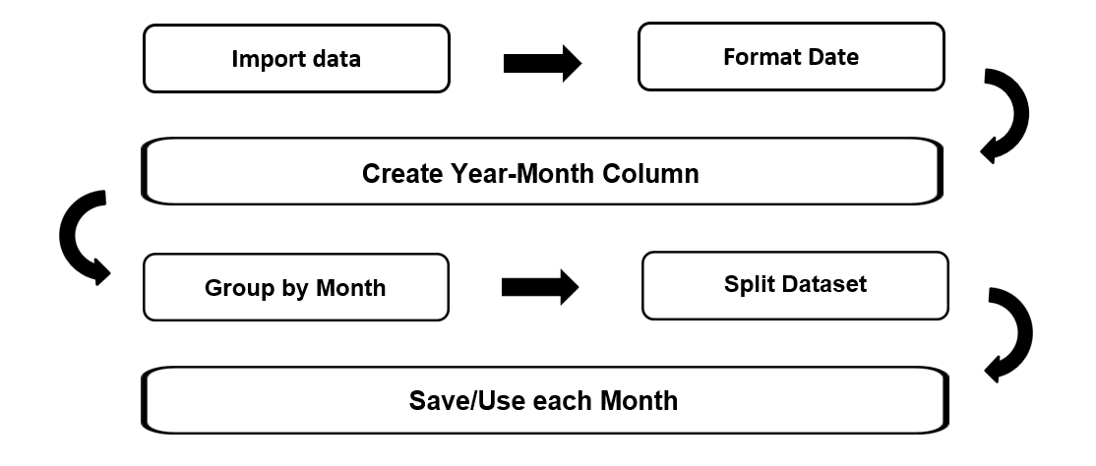
Fig : 2.2.1

4

CHAPTER 3
MODULE DESCRIPICTION

3.1 Data Import and Cleaning:

Handles all user input across the application,including validation and
preprocessing. Collects input from the user via the GUI. Validates input data (e.g., dates, room IDs, event details).Sends the processed data to relevant modules.

3.2 Date Transformation and Feature Engineering:

Create a consistent monthly identifier to group data by month.Extract year and month from date using lubridate::floor_date() or format().Add a new column (e.g., year_month) for grouping

3.3 Module 3 : Grouping and Splitting Data:
Organize data by month and split it into monthly subsets for focused analysis.Group data by year_month using dplyr::group_by().Split grouped data into a list of monthly tibbles using group_split()

3.4 Module 4 : Functional Processing of Monthly Subsets:
Automate further processing on each monthly subset.Use purrr::map() or loops to apply functions such as summarization, visualization, or export on each monthly tibble

CHAPTER 4
CONCLUSION & FUTURE SCOPE

Conclusion

This Splitting a dataset into monthly subsets using tidyr and dplyr is a powerful approach for organizing and analyzing time-series or date-based data. By first ensuring the presence of a properly formatted date column, and then using functions like mutate() to extract the year and month, we can group the data meaningfully by time intervals. The group_by() function allows us to define these monthly groups, and group_split() or nest() provides a convenient way to separate the data into individual tibbles for each month.
This method enhances both analytical flexibility and performance, especially when dealing with large datasets or performing operations that vary over time. It allows for:
- Isolated Analysis: Each monthly subset can be analyzed independently, making it easier to identify seasonal patterns, outliers, or monthly trends.
- Improved Readability: Organizing data by month reduces clutter and makes downstream tasks—like visualization or modeling—more structured.
- Modular Processing: Data engineers and analysts can apply different preprocessing steps or models to different months, if needed.
Overall, this workflow improves clarity, reproducibility, and scalability in time-based data workflows. It is a foundational technique in exploratory data analysis (EDA), forecasting, and reporting tasks

Future Scope

ISplitting a dataset into monthly subsets using tidyr and the tidyverse ecosystem is a common data preparation step, especially for time series and temporal analysis. Currently, this is typically done using a combination of dplyr for data manipulation and lubridate for date handling, where the date column is transformed using floor_date() to extract the month, followed by group_by() and nest() or group_split() to create monthly subsets. Looking forward, the future scope includes more intuitive and time-aware functionality within tidyr itself, potentially allowing for declarative syntax to split data by time intervals like months, weeks, or quarters without manually adjusting date formats. This could be facilitated by tighter integration with packages such as clock and tsibble, which provide advanced tools for time-based data structures. Additionally, as interactive data applications like Shiny continue to grow, we may also see enhanced support for dynamic and reactive time-based subsetting directly within tidyverse pipelines. Overall, the direction points toward more seamless, readable, and powerful tools for managing and analyzing time-based data within the tidyverse framework.

APPENDIX A
SOURCE CODE
library(shiny)
library(tidyverse)
library(lubridate)

ui <- fluidPage(
titlePanel("Monthly Dataset Splitter"),

sidebarLayout(
sidebarPanel(
fileInput("file", "Upload CSV File", accept = ".csv"),
uiOutput("date_col_ui"),
actionButton("split_btn", "Split by Month")
),

mainPanel(
uiOutput("month_tabs")
)
)
)

server <- function(input, output, session) {
dataset <- reactiveVal(NULL)
split_data <- reactiveVal(list())

observeEvent(input$file, {
req(input$file)
df <- read_csv(input$file$datapath, show_col_types = FALSE)
dataset(df)
})

output$date_col_ui <- renderUI({
req(dataset())
selectInput("date_col", "Select Date Column", choices = names(dataset()))
})

observeEvent(input$split_btn, {
req(dataset(), input$date_col)
df <- dataset()

# Convert to Date
df <- df %>%
mutate(Date = as.Date(.data[[input$date_col]])) %>%
filter(!is.na(Date)) %>%
mutate(Month = floor_date(Date, unit = "month"))

# Split into list by Month
split_list <- split(df, df$Month)
split_data(split_list)
})

output$month_tabs <- renderUI({
req(split_data())
tabs <- lapply(names(split_data()), function(month) {
df <- split_data()[[month]]
tabPanel(
month,
downloadButton(paste0("download_", month), paste("Download ", month)),
tableOutput(paste0("table_", month))
)
})
do.call(tabsetPanel, tabs)
})

observe({
req(split_data())
lapply(names(split_data()), function(month) {
local({
m <- month
df <- split_data()[[m]]
output[[paste0("table_", m)]] <- renderTable({
head(df, 10)
})

output[[paste0("download_", m)]] <- downloadHandler(
filename = function() paste0("data_", m, ".csv"),
content = function(file) {
write_csv(df, file)
}
)
})
})
})
}

shinyApp(ui, server)

APPENDIX B
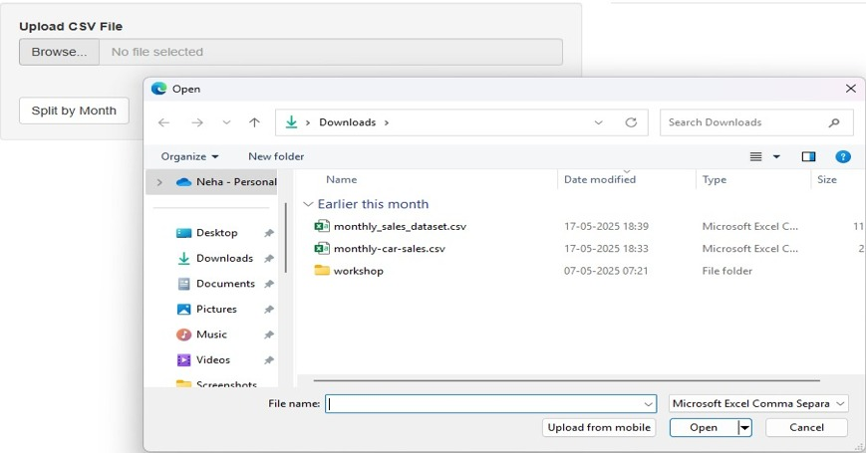
SCREENSHOTS

Fig. B. Uploading file
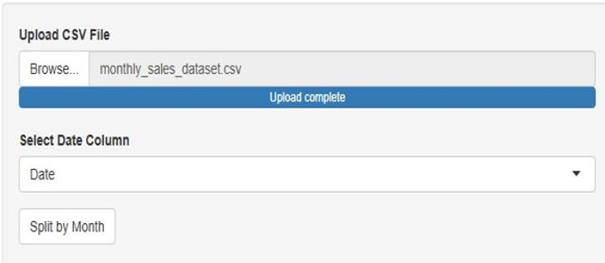

Fig. B. File uploaded

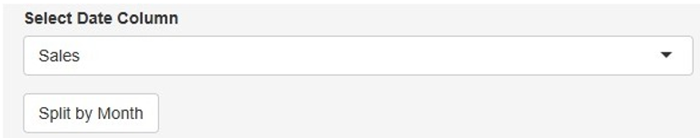
Fig. B. Select date column

12
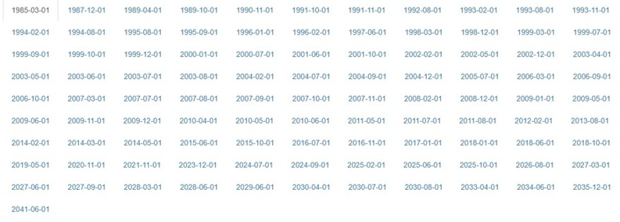
Fig. B. Date categorization
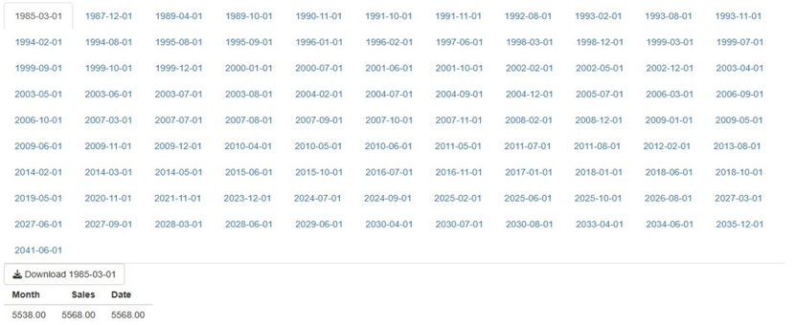
Fig. B. Data splitted according to month

REFERENCES

Wickham, H., François, R., Henry, L., & Müller, K. (2023). dplyr: A Grammar of Data Manipulation. R package version 1.1.4. Available at: https://CRAN.R-project.org/package=dplyr

Wickham, H. (2023). tidyr: Tidy Messy Data. R package version 1.3.0. Available at: https://CRAN.R-project.org/package=tidyr

Wickham, H. et al. (2019). Welcome to the tidyverse. Journal of Open Source Software, 4(43), 1686. DOI: 10.21105/joss.01686

R Core Team (2024). R: A language and environment for statistical computing. R Foundation for Statistical Computing, Vienna, Austria. Available at: https://www.R-project.org/

